Executive Summary

Albatross algorithm is a disruptive innovation for tail risk hedging sector because it promises better quality and higher reliability for significantly lower cost. This venture aims to profit from this strategy by implementing Albatross algorithm as a proprietary risk management mechanism of a Fortune 100 corporation and managing 20 billion USD of that company.

1.1 Sector

Tail Risk Hedging Funds (TRHFs) aim to protect investors against catastrophic losses in financial meltdowns. Currently, TRHFs and Black Swan funds (BSFs) are used interchangeably because all current TRHFs use Black Swan strategy (constantly purchasing deep out of money put options).

Sector size has grown from 400 million USD in 2007 to 70+ billion USD in 2015. Biggest competitor is PIMCO with 50+ billion USD in its tail risk hedging products. Second and the oldest one is Universa. Its AUM is 6 billion USD. There are also 10-15 smaller funds.

1.2 Main Problem

Long term performance of BSFs is always negative. Although it is acceptable for insurance products, their cost is not worth their benefit. Annual cost of BSF protection is 150 – 200 basis points. An investor with a balanced portfolio should sacrifice 25% - 30% of his annual return to purchase BSF protection. Moreover, BSFs prone to generate negative returns in extended financial crises due to buying overvalued options. Since they are neither cost-effective nor reliable, large companies and pension funds either don’t invest in BSFs or allocate only 1% - 2% to attenuate their adverse effects on total portfolio return. Insufficient allocation leads to insufficient protection when financial crisis occurs.

  - Solution and Competitive Edge:

Albatross algorithm generates higher returns in financial crises than BSFs (better protection). Its possibility of generating high returns in bearish markets is higher than BSFs (more reliable). While BSFs reduce investors’ total return, Albatross algorithm improves it (cost effective).

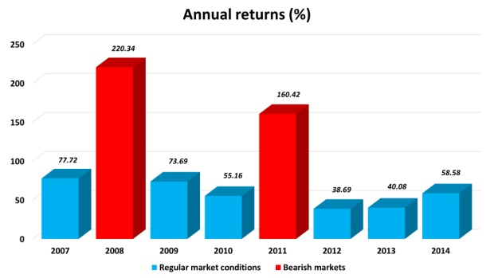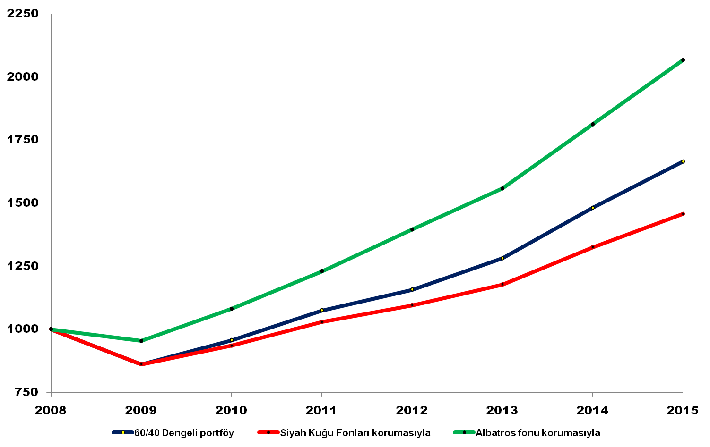
Comparison of BSFs and Albatross algorithm

Blue: 60/40 balanced portfolio (annual return: 7.56%)
Red: If 5% is allocated to Eurekahedge TRHF Index, annual return would be reduced by 27% (5.52%)
Green: If 5% is allocated to Albatross algorithm, annual return would be increased by 45% (10.92%)
- Better protection: Generates higher return than BSFs in financial crises
- Cost effective: Improves performance of the core portfolio, unlike BSFs
- Reliable: Has higher possibility of generating high returns in financial crises

Compound annual return: 82.49% Calmar: 6.44
Worst DD: -14.58% Average M/E: 16.75%
1.4 Main Benefit

Albatross algorithm is capable of rendering any large cap corporation (or a pension fund or a sovereign wealth fund) highly resilient to all kind of financial crises.

Had “Albatross algorithm” been implemented to Citigroup, for example, it would have compensated 29 billion USD loss of Citigroup in 2008, completely. As a result, market value of Citigroup would have never fallen below 50 billion USD (it fell below 10 billion USD), and its current market value would be greater than 200 billion USD today, instead of 125 billion USD (as of March 2016).

1.5 Target Market

- Fortune 100 corporations
- Sovereign states (Ministries of Finance, Central banks, Sovereign wealth funds)
- Large pension funds

1.6 Management

Zafer Ulgez, Founder: Worked in Industrielle Alliance as a financial analyst. Certified in Derivatives Markets Strategies. Passed all 3 CFA (Chartered Financial Analyst) exams. Traded in CME and ICE futures exchanges. Developed Albatross algorithm. He will hire a professional CEO to manage Yamaska Capital before asset management firm is registered.

1.7 Implementation Strategy

Coding (proof of concept): The algorithm will be coded in 3-4 months. This stage will provide tangible proof for investor
Improvements: Some concepts will be tested and incorporated into the algorithm (4 months)
Connectivity: The algorithm will be converted into automated trading software in another 4 months.
Track record: 3 million USD will be managed for 2 years to establish a sound track record
Tail risk hedging fund: Company will manage proprietary fund of a Fortune 100 firm. Initial fund will be at least 300 million USD and increases in time to reach target AUM of 20 billion USD in 4-5 years.
Exit: The algorithm will be sold to the Fortune 100 firm.

